Negative fuzzy rule generation for classification with small disjunct problem

Rui Min

a Alberto, Granada, Spain

b Frecisco,Granada, Spain

Submitted: 12 Feb. 2015 — Accepted: 12 Feb. 2015 — Published: 12 Feb. 2015

***Abstract****—*This paper presents the theory of negative fuzzy rule generation for classification with small disjunt issue. It introduces the current issue of classification for small disjunct. For resolving the issue, we introduce first step to identify the possible fuzzy set with small disjunt. The second step is to make more granularity of that fuzzy set. The third step is to do association rule classification in that special fuzzy set. The last step is to generate negative fuzzy rules. With positive rules and negative rules, we can get clear classification results. When a test data comes, it goes first to look for negative rule fuzzy set. If it meets the negative fuzzy set, then it will goes for negative fuzzy rules. If not, then check if it meets the positive fuzzy set. If it does, then it will goes to the positive fuzzy rules.

***Keywords***—fuzzy set; association rule classification; negative rule.

———————————————————— ◆ ————————————————————

# Introduction

A

sociation rule classification is widely used in different areas. It works well to have good classification ability for real word use cases. But as we all known once there are small disjunct mix in certain class area. The accurate of classification will reduce. Also the small disjunct can be very interesting group that we should classify them. For example if we consider the petrol mining and certain illness identification. They all can be small disjuncts.

For using association rule in classifier there is new problem that has been found. For many data their attibutes are quantitative values as the above example in a database. To find frequency items we need subdivision of the quantitative values into crisp sets. It would lead to over or under estimating values near the borders, which is called “sharp boundary problem”.

For overcoming that problem fuzzy set was introduced to make the intervals are overlap instead of crisp set. We can use fuzzy membership function to do fuzzy partitioning to get the crisp set (fuzzy set).

*Fuzzy rule based classification system(FRBCS):* is a classification system that is using fuzzy classification association rule to classify data.

*Support and confidence:* through the fuzzy set and frequent related attibutes we can get a fuzzy association classification rule A🡪Cj,with support and confidence defined as blow.C is the class label.

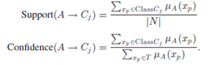

Chi algorithm is one of the FRBC algorithm which is very famous and typical. It generates the fuzzy rule base(RB) based the features fuzzy set with following steps:

1. Establishment of the linguistic partitions. Once the domain of variation of each feature is determined, the fuzzy partitions are computed.
2. Generation of a fuzzy rule for each example data : xp=(xp1,xp2,……,xpn,Cp)  
     
   For this it is necessary:  
     
   2.1 To compute the matching degree u(xp) of the example to the different fuzzy regions using a conjunction operator(usually modeled with a minimum or product T-norm).  
     
   2.2 To assign the example xp to the fuzzy region with the greatest membership degree.  
     
   2.3 To generate a rule for the example, whose antecedent is determined by the selected fuzzy region and whose consequent is the label of class of the example.  
     
   2.4 To compute the rule weight. We must remark that rules with the same antecedent can be generated during the learning process. If they have the same class in the consequent, we just remove one of the duplicated rules, but if they have a different class only the rule with the highest weight is kept in the RB.

The Chi algorithm works well but when facing the small disjuncts the accurate decrease. Small disjunct problem was first describe and definition by Acker,Hotel and Porter[Ahp89].Small disjunt issue has been deeply researched by different researchers.The common sense of it is : the rule based classification have strong affection by small disjuncts.

For resoving the small disjunct issue we think about exception rule also called negative rule:

In certain fuzzy partition, large clusters of examples of the same class, we can get postive rule as:

Xp1,xp2,xp3--> C1

Small clusters of examples of the same class,we can get negative rule as :

Xp1,xp2,xp3--> ~C1

We did the experiments to investigate the small disjunct affection.

Experiment One:

In the area 1 and area 3 we can see the small disjuncts exist.

|  |  |
| --- | --- |
| Feature 1 :0-5  Feature 2:0-10 | 300 numbers red class data  80 numbers green class data (small disjunct) |
| Feature 1 :5-10  Feature 2:0-10 | 200 numbers green class data  60 numbers green class data (small disjunct) |

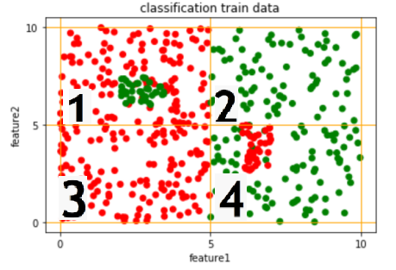

|  |
| --- |
| 0 is read, and 1 is green |
| 1: feature1 IS L\_0 AND feature2 IS L\_1: 0 with Rule Weight: 0.40785471083683394 |
| 2: feature1 IS L\_1 AND feature2 IS L\_1: 1 with Rule Weight: 0.24215480715170346 |
| 3: feature1 IS L\_0 AND feature2 IS L\_0: 0 with Rule Weight: 0.5314227804905316 |
| 4: feature1 IS L\_1 AND feature2 IS L\_0: 1 with Rule Weight: 0.15434764907782308 |

Through the experiments that we did we found out the below results:

1. The small disjunct decrease the accurate. The area 1 and area 3 has the same red class data , but because the small disjunct the rule weight decrease from 0.53 to 0.41.  
   Area 2 and Area 4 have the same situation , area 4 with small disjunct the rule weigth is 0.15 , is less than area 2 without small disjunct , witch the rule weight is 0.24.
2. Area 2 does not have small disjunct but because the number of green class is less than area 1 and area 3 so the rule weight is 0.24 lesser.

Small rule weight does not mean has disjunct. Please refer the area 2. This is because the class data are less compared with other class.

Experiment Two:

|  |  |
| --- | --- |
| Feature 1 :0-5  Feature 2:0-10 | 300 numbers red class data  85numbers green class data (small disjunct) |
| Feature 1 :5-10  Feature 2:0-10 | 300numbers green class data  42numbers green class data (small disjunct) |

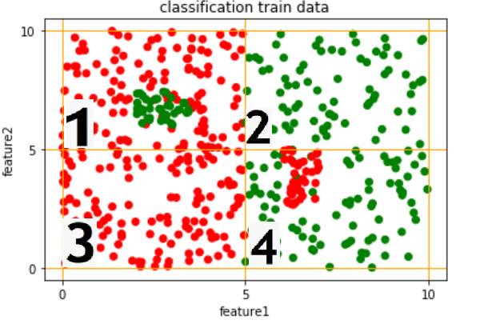

|  |
| --- |
| 1: feature1 IS L\_0 AND feature2 IS L\_1: 0 with Rule Weight: 0.21488828825244272 |
| 2: feature1 IS L\_1 AND feature2 IS L\_1: 1 with Rule Weight: 0.47985987669886204 |
| 3: feature1 IS L\_0 AND feature2 IS L\_0: 0 with Rule Weight: 0.36564366761409983 |
| 4: feature1 IS L\_1 AND feature2 IS L\_0: 1 with Rule Weight: 0.39859118979909935 |

We can see area 1 and 3 has the smilar number of red class data but area 1 has small disjunct , then rule weight is 0.21 and area 3 doesnt has , rule weight is 0.37.(15% different)

Area2 and area 4 has the the similar green class number, but area 2 has rule weight 0.48 and area 4 has rule weight 0.40.(8% different). The small disjunct has lower impacted since the disjunt number is 42 which is less than 85 numbers than area 1.

So we got conclusion that the disjunct is bigger ,then the impacted bigger.

Experiment 3

If we reduce the small disjunct area the other class number, then the small disjunct will not small disjunct according to that area, we will see if we can get the classification rule in that area.

|  |  |
| --- | --- |
| Area 1:  Feature 1: 0-5  Feature 2: 5-10 | 100 numbers red class data  85 numbers green class data (small disjunct) |
| Area 2:  Feature 1: 5-10  Feature 2: 5-10 | 300 numbers red class data |
| Area 3:  Feature 1: 0-5  Feature 2: 0-5 | 300 number green class data |
| Area 4:  Feature 1: 5-10  Feature 2: 0-5 | 100 numbers green class data  42 numbers green class data (small disjunct) |

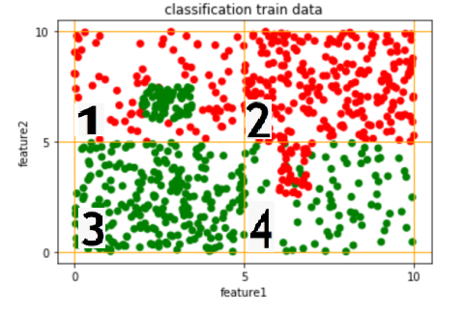

|  |
| --- |
| 1: feature1 IS L\_0 AND feature2 IS L\_1: 0 with Rule Weight: 0.0896019693858204 |
| 2: feature1 IS L\_1 AND feature2 IS L\_1: 0 with Rule Weight: 0.5821283301101596 |
| 3: feature1 IS L\_0 AND feature2 IS L\_0: 1 with Rule Weight: 0.6373284639776884 |
| 4: feature1 IS L\_1 AND feature2 IS L\_0: 1 with Rule Weight: 0.21307566978851653 |

Conclusion :

We can see area 2 and 3 which do not have small disjunct and have more quantity same class data, have high weight rules 0.58 and 0.64, area 1 and 4 which have small disjunct and disjunct quantity are different, then their rule weight are 0.0896 and 0.213 , which are quite different.

With more bigger small disjunct the rule weight are more small. With small disjunct the areas have smaller rule weights.

Experiment 4

If we have small disjunct in the area wich has more quantity of same class data, other areas have less data. We will see if the rule weigh of small disjunct area 1 and 4 will be lesser than areas 2 and 3 which do not have disjuncts.

|  |  |  |  |
| --- | --- | --- | --- |
| Area 1:  Feature 1: 0-5  Feature 2: 5-10 | 388 numbers red class data  85 numbers green class data (small disjunct) |  |  |
| Area 2:  Feature 1: 5-10  Feature 2: 5-10 | 100 numbers red class data |  |  |
| Area 3:  Feature 1: 0-5  Feature 2: 0-5 | 100 number green class data |  |  |
| Area 4:  Feature 1: 5-10  Feature 2: 0-5 | 388 numbers green class data  42 numbers green class data (small disjunct) |  |  |

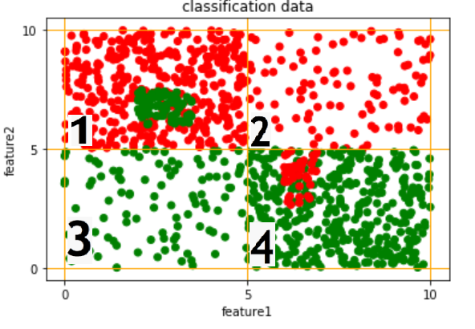

|  |
| --- |
| 1: feature1 IS L\_0 AND feature2 IS L\_1: 0 with Rule Weight: 0.467654487161886 |
| 2: feature1 IS L\_1 AND feature2 IS L\_1: 0 with Rule Weight: 0.22130081612398034 |
| 3: feature1 IS L\_0 AND feature2 IS L\_0: 1 with Rule Weight: 0.24582965430189518 |
| 4: feature1 IS L\_1 AND feature2 IS L\_0: 1 with Rule Weight: 0.6081975264697139 |

Experiment 4 result is :

We cannot know if the fuzzy set area has small disjunct or not through the rule weight.

Through all the above experiments and research , we get the below method to classify the small disjunct:

Step1 : We can get negative rules through the positive rule first, each positive rule can generate one co-responding negative rule. F1 L0,f2 L0-->class1 , negative rule: f1L0,f2L0-->~class1(f1L0,f2L0-->class2 , f1L0,f2L0-->class3......)

Step2 : Use the train data to validate if the negative rule has enough rule weight (high confident)

Step3: More granularity in the negative rule area, get positive rules 2

Step4: In the positive rules, the rules have different class result than the previous rules in the same areas ,called priority rules, final negative rules. Then delete all other small rules, keep the original first normal rules.

How test data to be classified:

When the new test data come, use the priority negative rule first, if it is not in the rule area, then look for the normal positive rules.

the two columns is 6mm (0.24 in). Paragraph indentation is 5 mm (0.1969 in), and spacing between paragraphs is 3pt.

Left- and right-justify your columns. Use tables and figures to adjust column length. On the last page of your paper, adjust the lengths of the columns so that they are equal. Use automatic hyphenation and check spelling. Digitize or paste down figures.

Possible area with small disjunct

**Table I**  
Different Styles for Different Parts of The Paper

|  |  |
| --- | --- |
| **Manuscript Part** | **Style to be used** |
| Paper Title | A-PaperTitle |
| Authors | A-Author |
| Affiliations | A-Affiliation |
| History | A-History |
| Abstract | A-Abstract |
| Keywords | A-Keywords |
| Main Headings | A-Heading 1 |
| Acknowledgement and References Section Title | B-Heading 1 |
| 2nd Headings | A-Heading 2 |
| 3rd or more Headings | A-Text + Bold-Italic |
| Text in Paragraphs | A-Text |
| Table Headers | A-TableHeader |
| Figure Captions | A-FigureCaption |
| Text in Figures and Tables | A-Fig\_Table\_Text |
| Equations | A-Equations |
| References | A-References |
| Biography | A-Biography |

Position figures and tables at the tops and bottoms of columns. Avoid placing them in the middle of columns. Large figures and tables may span across both columns. Figure captions should be centered below the figures; table captions should be centered above. Avoid placing figures and tables before their first mention in the text. Use the abbreviation “Fig. 1,” even at the beginning of a sentence.

\* Corresponding Author: One of the Authors

*E-mail:* … Phone: … FAX: … (If any)

This project was supported by …………, Grant No. …

© International Computer Science and Engineering Society (ICSES)

Figure axis labels are often a source of confusion. Use words rather than symbols. For example, write “Magnetization,” or “Magnetization, M,” not just “M.” Put units in parentheses. Do not label axes only with units. In the example, write “Magnetization (A/m)” or “Magnetization (A⋅m1).” Do not label axes with a ratio of quantities and units. For example, write “Temperature (K),” not “Temperature/K.”

Multipliers can be especially confusing. Write “Magnetization (kA/m)” or "Magnetization (103 A/m).” Figure labels should be legible, about 10-point type.

References

Very important is that we use IEEE reference style with DOI at the end of each reference. A simple yet safe way is to use <https://search.crossref.org/> in order to find the reference; then, follow “Actions”->”Cite”->”IEEE” to get the right format for a reference. To find all the DOIs of your references, you can use <https://apps.crossref.org/SimpleTextQuery>. Number citations consecutively in square brackets [1]. Punctuation follows the bracket [2]. Refer simply to the reference number, as in [3], or in [3] and [4], or in [3]-[5], or in [3], [6]-[9], and [11]. Use “Ref. [3]” or “Reference [3]” at the beginning of a sentence:

“Reference [3] was the first ...”. A complete reference guide can be downloaded from <https://www.ieee.org/conferences_events/conferences/publishing/style_references_manual.pdf>

Number footnotes separately in superscripts. Place the actual footnote at the bottom of the column in which it was cited. Do not put footnotes in the reference list. Use letters for table footnotes.

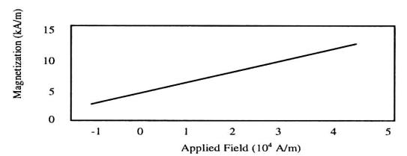

1. Magnetization as a function of applied field. Note how the caption is centered in the column

Give all authors’ names; use “et al.” if there are six authors or more. Papers that have not been published, even if they have been submitted for publication, should be cited as “unpublished” [4]. Papers that have been accepted for publication should be cited as “in press” [5]. In a paper title, capitalize the first word and all other words except for conjunctions, prepositions less than seven letters, and prepositional phrases.

For papers published in translated journals, first give the English citation, then the original foreign-language citation [6].

Abbreviations and Acronyms

Define abbreviations and acronyms the first time they are used in the text, even after they have been defined in the abstract. Abbreviations such as ICSES, SI, MKS, CGS, sc, dc, and rms do not have to be defined. Do not use abbreviations in the title unless they are unavoidable.

Equations

Equations must be produced using the Microsoft Word Built-in Equation Editor. Number equations consecutively with equation numbers in parentheses flush with the right margin, as in (1). To make your equations more compact, you may use the solidus (/), the exp function, or appropriate exponents. Italicize Roman symbols for quantities and variables, but not Greek symbols. Use an en dash (−) rather than a hyphen for a minus sign. Use parentheses to avoid ambiguities in denominators. Punctuate equations with commas or periods when they are part of a sentence, as in

**Table II**  
Type Sizes for Camera-Ready Papers

| Type size (pts.) | Appearance | | |
| --- | --- | --- | --- |
| Regular | Bold | Italic |
| 7 | Text in tables and figures, footnotes, text subscripts and superscripts. |  |  |
| 8 | References, biography. | table captions, figure captions |  |
| 9 | Authors’ affiliations, main text, equations, Abstract, Keywords. | Heading 2  Subheading | |
| 10 | Authors’ names. | Heading 1 |  |
| 18 | Paper title |  |  |

 (1)

Symbols in your equation should be defined before the equation appears or immediately following. Use “(1),” not “Eq. (1)” or “equation (1),” except at the beginning of a sentence: “Equation (1) is ...”. Line spacing before and after an equation is 3pt.

Other Recommendations

The Roman numerals used to number the section headings are optional. If you do use them, do not number Acknowledgments and References, and begin Subheadings with letters. Use two spaces after periods (full stops). Hyphenate complex modifiers: “zero-field-cooled magnetization.” Avoid dangling participles, such as, “Using (1), the potential was calculated.” Write instead, “The potential was calculated using (1),” or “Using (1), we calculated the potential.”

Use a zero before decimal points: “0.25,” not “.25.” Use “cm3,” not “cc.” Do not mix complete spellings and abbreviations of units: “Wb/m2” or “webers per square meter.” not “webers/m2.” Spell units when they appear in text: “...a few henries,” not “...a few H.” If your native language is not English, try to get a native English-speaking colleague to proofread your paper. Do not add page numbers.

# Units

Use either SI (MKS) or CGS as primary units. (SI units are encouraged.) English units may be used as secondary units (in parentheses). An exception would be the use of English units as identifiers in trade, such as “3.5-inch disk drive.”

Avoid combining SI and CGS units, such as current in amperes and magnetic field in oersteds. This often leads to confusion because equations do not balance dimensionally. If you must use mixed units, clearly state the units for each quantity that you use in an equation.

# Some Common Mistakes

The word “data” is plural, not singular. The subscript for the permeability of vacuum is zero, not a lowercase letter “o.” In American English, periods and commas are within quotation marks, like “this period.” A parenthetical statement at the end of a sentence is punctuated outside of the closing parenthesis (like this). (A parenthetical *sentence* is punctuated within the parentheses.) A graph within a graph is an “inset,” not an “insert.” The word alternatively is preferred to the word “alternately” (unless you mean something that alternates). Do not use the word “essentially” to mean “approximately” or “effectively.” Be aware of the different meanings of the homophones “affect” and “effect,” “complement” and “compliment,” “discreet” and “discrete,” “principal” and “principle.” Do not confuse “imply” and “infer.” The prefix “non” is not a word; it should be joined to the word it modifies, usually without a hyphen. There is no period after the “et” in the Latin abbreviation “et al.” The abbreviation “i.e.” means “that is,” and the abbreviation “e.g.” means “for example.” An excellent style manual for science writers is [7].

##### Acknowledgment

The preferred spelling of the word “acknowledgment” in America is without an “e” after the “g.” Try to avoid the stilted expression, “One of us (R.B.G.) thanks ...” Instead, try “R.B.G. thanks ...” Put sponsor acknowledgments in the unnumbered footnote on the first page.

##### References

* [Ahp89]:Acker,L.,Holte,R.C,&Porter,B.W.(1989).Concept Learning and the Problem of Small Disjuncts. IJCAI.
* [Journal Paper]: J. Bhat, and H. R. Bomer, "Manuscript Title," *Journal Title (italic)*, vol. x, no. y, pp. 1-20, 2018. DOI: xyz (Do not use dot “.” after any DOI or ISBN)
* [Conference Paper]: J. Bhat, M. Chen, and H. R. Bomer, "Manuscript Title," in proc. *Conference Title (italic)*, vol. x, no. y, pp. 1-20, New York, USA, Feb. 2018. DOI: xyz
* [Book]: J. Clerk Maxwell, *Book Title (italic)*, vol. II, 3rd ed., Oxford: Clarendon, 1892, pp. 68–73. DOI or ISBN: xyz
* [Book Chapter]: J. Bhat, and H. R. Bomer, "Chapter Title," in *Book Title (italic)*, vol. II, 3rd ed., NY, USA: Springer, ch. II, sec. 2.1, 2018, pp. 1-20. DOI: xyz
* [Technical Report]: J. K. Author, “Title of report,” Abbrev. Name of Co. or Uni., City of Co. or Uni., Abbrev. State, Rep. xxx, year.
* [Theses (M.S.) and Dissertations (Ph.D.)]: J. K. Author, “Title of thesis,” M.S. or Ph.D. thesis, Abbrev. Dept., Abbrev. Univ., City of Univ., Abbrev. State, year.
* [Patent]: J. K. Author, “Title of patent,” U.S. Patent x xxx xxx, Abbrev. Month, day, year.
* The followings are some samples:

Intel official website, [http://intel.com](http://intel.com" \t "_blank), 2018.

G. Eason, B. Noble, and I. N. Sneddon, “On certain integrals of Lipschitz-Hankel type involving products of Bessel functions,” *Phil. Trans. Roy. Soc. London*, vol. A247, no. 2, pp. 529–551, April 1955. DOI: xyz.

J. Clerk Maxwell, *A Treatise on Electricity and Magnetism*, vol. 2, 3rd ed., Oxford: Clarendon, 1892, pp.68–73. ISBN: xyz

I. S. Jacobs, and C. P. Bean, “Fine particles, thin films and exchange anisotropy,” in *Magnetism*, Vol. III, G. T. Rado and H. Suhl, Eds., New York: Academic Press, 1963, pp. 271–350. DOI: xyz

R. Nicole, “Title of paper with only first word capitalized,” *J. Name Stand. Abbrev.*, In Press, pp. 1-20, 2018. DOI: xyz

Y. Yorozu, M. Hirano, K. Oka, and Y. Tagawa, “Electron spectroscopy studies on magneto-optical media and plastic substrate interface,” in proc. *9th Annual Conf. Magnetics Japan*, vol. x, no. y, pp. 301-308, NY, USA, Jun. 1982. DOI: xyz

M. Young, *The Technical Writer's Handbook*. Mill Valley, CA: University Science, 1989. ISBN: xyz

E. E. Reber, R. L. Michell, and C. J. Carter, “Oxygen absorption in the earth’s atmosphere,” Aerospace Corp., Los Angeles, CA, Tech. Rep. TR-0200 (4230-46)-3, Nov. 1988.

**First author** and the other authors should include biographies at the end of regular papers. Biographies are often not included in conference-related papers. First of the paragraph may contain a place and/or date of birth (list place, then date). Next, the author’s educational background is listed. The degrees should be listed with type of degree in what field, which institution, city, state or country, and year degree was earned. The author’s major field of study should be lower-cased. Job titles are capitalized. The current job must have a location; previous positions may be listed without one. Information concerning previous publications may be included. Try not to list more than three books or published articles. The format for listing publishers of a book within the biography is: title of book (city, state: publisher name, year) similar to a reference. Current and previous research interests end the paragraph.

##### Manuscript Preparation Checklist

This checklist should be filled by the corresponding Author after the submitted manuscript is accepted.

|  |  |  |  |
| --- | --- | --- | --- |
| **Part** | **Rule** | **Confirm by Author** | **Confirm by ICSES** |
|  | Paper Size is A4, and Paper Margins are correct (I used ICSES-Manuscript-Template.doc). |  |  |
| **Header** | Journal Title was set correctly |  |  |
| Vol., No., Month and Year were set based on the acceptance e-mail. |  |  |
| Page Numbers was set based on the acceptance e-mail. |  |  |
| **Footer** | Manuscript ID is based on the acceptance e-mail. |  |  |
| Copyright Year is correct. |  |  |
| Journal ISSN is correct. |  |  |
| **Title Page** | Manuscript Title is checked, and it is same with the one in the system. |  |  |
| Manuscript Title is Capitalized for each words (except Prepositions) |  |  |
| The Style of Manuscript Title is A-PaperTitle |  |  |
| I certify that the List of Authors is complete and correct, and same with the one in the system. |  |  |
| The Style for List of Authors is A-Author. |  |  |
| I certify that the List of Affiliations is complete and correct, and same with the one in the system. |  |  |
| The Style for List of Affiliations is A-Affiliation. |  |  |
| The history of paper (Submitted, Accepted and Published) is based on the acceptance e-mail. |  |  |
| The is an empty line before and another one after the History (font-size: 9). |  |  |
| There is a text-box at end of the first column to indicate corresponding author, grants, emails, copyright, and other extra information. |  |  |
| All the grants were stated in the text-box completely and exactly. |  |  |
| **Abstract** | “Abstract” is Bold-Italic. |  |  |
| There is a m-dash after the “Abstract”. |  |  |
| The Style for Abstract text is A-Abstract. |  |  |
| **Keywords** | “Keywords” is Bold-Italic. |  |  |
| There is a m-dash after the “Keywords”. |  |  |
| The Style for Keywords text is A-Keywords. |  |  |
|  | The separator (———————— ◆ ————————) exists in the correct location. |  |  |
|  | Rest of the paper is 2-column where column-width is 8.7cm and space between columns is 0.6cm. |  |  |
| **Headers** | I checked all the main Headers and they are correct and Capitalized for each words (except Prepositions) |  |  |
| The Style for main Headers is A-Heading 1. |  |  |
| I checked all the 2nd Level Headers and they are correct and Capitalized for each words (except Prepositions) |  |  |
| The Style for 2nd Level Headers is A-Heading 2. |  |  |
| I checked the Headers of “Acknowledgement” and “References” Section and they are correct and Capitalized for each words (except Prepositions) |  |  |
| The Style for main Headers is B-Heading 1. |  |  |
| **Introduction Section** | The First Section is “I. Introduction”. |  |  |
| The first letter of the first paragraph is a Drop-Cap with 2 rows. |  |  |
| The first word of the first paragraph is in UPPERCASE. |  |  |
| **Parageraphes** | The Style for all the paragraphs is A-Text. |  |  |
| There is not any empty Newline between Paragraphs or before/after any Heading. |  |  |
| **Tables** | Each Table is located in a district “Drawing Canvas”. |  |  |
| I checked all the Tables’ Headers and they are correct and Capitalized for each words (except Prepositions) |  |  |
| Tables’ Numbering is checked and they are correct. |  |  |
| All the Tables are cited in the manuscript text, and before the location of Table. |  |  |
| The Style of each Table Caption is A-TableHeader. |  |  |
| The Style for the text in the Tables is A-Fig\_Table\_Text (Font-size: 7). |  |  |
| There is 0.1cm margin in all the cells. |  |  |
| All the Tables are editable and created via Microsoft Office (Word, Excel, Visio etc.). |  |  |
| There is a newline before or after the Table where needed. |  |  |
| **Figures** | Each Figure is located in a district “Drawing Canvas”. |  |  |
| I checked all the Figures Captions and they are correct and Capitalized only for the first word. |  |  |
| Figures’ Numbering is checked and they are correct. |  |  |
| All the Figures are cited in the manuscript text, and before the location of Figure. I used “Fig. X” instead of “Figure X” in the text. |  |  |
| The Style of each Figure Caption is A-FigureCaption. |  |  |
| The Style for the text in the Figures is A-Fig\_Table\_Text (Font-size: 7). |  |  |
| All the Figures and Diagrams are editable and created via Microsoft Office (Word, Excel, Visio etc.). |  |  |
| Other Figures are in at least 300dpi. |  |  |
| There is a newline before or after the Figure where needed. |  |  |
| **Equations and Variables** | I checked all the Equations and they are correct, and have Numbering. |  |  |
| Equations are made using MathType or EquationEditor. |  |  |
| Equations are in order i.e. (1), (2), (3),…(*n*) |  |  |
| The Style of all the Equations is A-Equation. |  |  |
| All the parameters and variables in the paper are *Italic* like *p*2*, mn, In, k* etc*.* |  |  |
| **References and Citations** | I checked all the References; they are complete and in exact IEEE format with DOI. |  |  |
| The Style of all the References is A-References. |  |  |
| All the References were Cited in the text. |  |  |
| The citations are in chronological order i.e. [1], [2], [3]-[5], [6], … |  |  |
| **Biographies** | Biographies of all the Authors were provided. |  |  |
| Photos of all the Authors were provided in at least 300dpi (size: 2cm\*2.5cm). |  |  |
| The Style of all the Biographies is A-Biography. |  |  |

Herewith, as the Corresponding Author, I certify that all the confirmations are exact and correct, and I am fully responsible for the information I provided.

Full Name of the Corresponding Author

Date